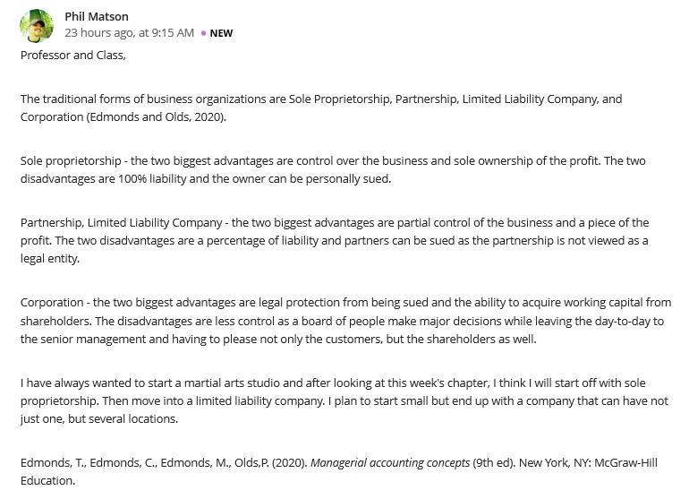
Reply 1
Hi! Matson
Venturing into business with a clear mind on the role that one has to play in the process, is absolutely an important aspect. It’s great to note that you have had a shift in mind on the actual type of business that you would like to establish. Most Individuals tend to fail in business due to lack of sufficient knowledge on the best type of business to establish. For example, one of the functional advantages of sole proprietorships is that they are easier to set up than other business entities. A person becomes a sole proprietor simply by running a business. Another functional advantage of a sole proprietorship is that the owner maintains 100% control and ownership of the business. With 100% commitment required of you, then you have to ensure that, you are not engaged in any other a business activities that will require your attention as well.
I wish you well as you plan to venture into business and I must state that your decision to start with Sole proprietorship remains to be a greater move.
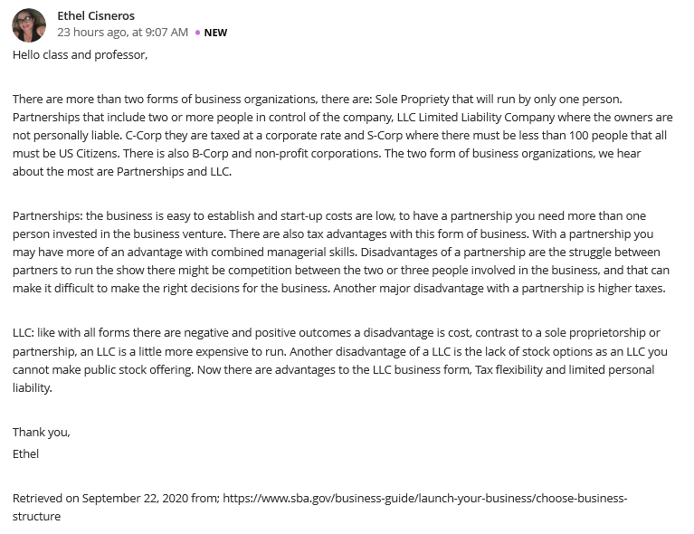
Reply 2
Hello Cisneros
As an Individual, I have had an interest in establishing a business. However, settling on the best type of business to venture into remains an Issue of great concern. For example, sole proprietorship has its own serious disadvantage which will require and individual to engage in a critical examination of all factors surrounding it before one can decide to set up such type of a business. In the case of a sole proprietorship business, one would realize that the business owner is liable personally for the debts of the business and for negligence and other personal liability which is absolutely different from the LLC and corporate forms of business, in which the liability of the owner is limited to the owner's investment.
Another type of business that I find to be more interesting and can have its own challenges is the partnership form of business. Like, before one can venture into it, there is need to be prepared with conflict resolutions skills because misunderstanding where there are more than 5 people will basically is common.

